Conjoint Analysis Project

We chose to do our conjoint analysis project on student’s preferences for colleges and the factors that influence the student’s school selection. Our target group was prospective or active students and recent graduates with an average age of 21 and a range from 18 - 24. There are many factors to consider when determining what influences students to select certain schools so we decided to focus on four of them. The important attributes we identified were the tuition costs, the number of enrolled students, the acceptance rate, and the school location.

We decided to account for the variation in tuition costs by using three different levels: $10,000 to represent low cost schools, $50,000 to capture high cost schools, and $30,000 to capture the middle ground. We believed that the expenses associated with a school is would greatly affect the appeal of that school to students. We expected to see this as a highly influential factor and we hypothesized students would be more interested in cheaper schools.

The number of enrolled students indicates how many current students the college has and we displayed the variation through three levels: 10,000, 20,000, and 30,000. We believed that the size of the student body at each school would be an influential factor in student’s decisions. If they want a more private education they would select a smaller school size and if the amount of activities and extracurriculars appealed to them, they would gravitate to a larger student body.

The acceptance rate is percentage of the students that were accepted out of those who applied which can demonstrate how prestigious or rigorous a college program is. Again, we chose three levels to represent this factor: 15%, 50%, and 85%. Students may prefer schools with a low acceptance rate because they feel it “weeds out” underperforming students and therefore is more prestigious. Conversely, a more generous acceptance rate may indicate to the student a “normal” level of difficulty in academics and therefore a more doable program.

The final factor we decided to look at was location. To measure this, we used a two-level selection: in state and out of state. We believed that students who placed a higher value on in-state schools are looking for convenience while those who preferred out-of-state colleges were looking for an experience.

In our original design we had a total of 54 profiles however, we decided to narrow the profiles down to ten for ease of ranking. We used the conjoint design to determine an optimal selection of eight profiles, but we were advised to raise that to ten. We collected data from 75 respondents for this analysis.

This was the format used to ask people to rank the university profiles.

Please rank the following ten university profiles from the most preferable to the most preferable (1) to the least preferable (10) when choosing a school to attend:

|  |  |  |  |  |
| --- | --- | --- | --- | --- |
| Tuition | Size | Acceptance Rate | Location | Your Rank |
| $10,000 | 20,000 | 50% | Out of State |  |
| $50,000 | 30,000 | 85% | Out of State |  |
| $50,000 | 20,000 | 85% | In State |  |
| $50,000 | 10,000 | 50% | Out of State |  |
| $30,000 | 30,000 | 50% | In State |  |
| $50,000 | 10,000 | 15% | In State |  |
| $30,000 | 10,000 | 85% | Out of State |  |
| $30,000 | 20,000 | 15% | Out of State |  |
| $10,000 | 30,000 | 15% | Out of State |  |
| $10,000 | 10,000 | 85% | In State |  |

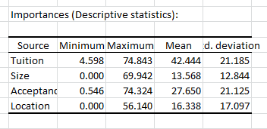

We were able to determine that students prefer schools with lower tuition ($10,000 a year) to schools with higher tuition ($30,000 or $50,000 a year). Our data also indicated that a school’s acceptance rate of 50% is preferable to an acceptance rate of 15% or 85%, however, the 15% is preferable to 85%. Students also demonstrated that an in-state location is more preferable to an out of state school. Lastly, a student body size of 20,000 students is preferable to a smaller school of 10,000 or a larger school of 30,000.

From this we are able to identify the ideal profile would be a medium sized school with approximately 20,000 students, a low tuition cost of $10,000, a moderate acceptance rate of 50%, located in-state.

Our data indicated that the average weight of importance placed on tuition is 42.4%, this was the most heavily weighted factor in the average student’s school decision. The second most important factor is the acceptance rate of the school with a rate of 27.6%. Next, the location of the school, in state or out of state, had a weight of 16.3%. The least weighted factor was the size of the school in terms of the number of students. This factor had a weight of 13.5%.

Now coming to the market share generation, we have taken a profile that we didn’t select from our 54 profiles, one such profile was:

10000 20000 0.5 In State

We took the above profile and pitted it against existing two profiles which are:

10000 20000 0.5 Out of State

50000 30000 0.85 Out of State

So, the total simulated market is:

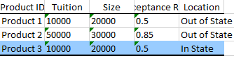

Now after running the market generation and market simulation tool, we get the following results:

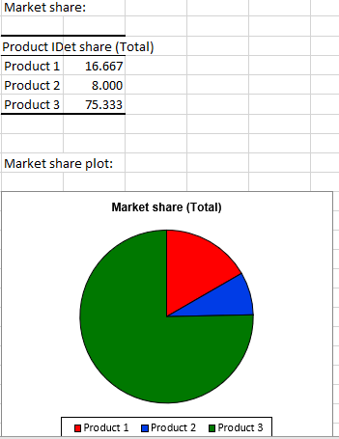

Product 3 is our new product. We can see that Product 3 took around 75.3% market share with the existing ones 16.66% and 8% respectively.